Lex Database - Dev Guidelines (Phase II)
Lex Database - Dev Guidelines (Phase II)
Work log
2025-04-22:
Intro
Milestone 1: Email Notifications
Database table data
Email template:
Additional information for developer guidelines
Quotation Request
Test Account
General Guidelines
Notes on future milestones [ON hold]
New task

Work log
2025-04-23:

Intro
1. We have a SaaS with several features that is already used by our customers. It is built on:

- WordPress and WooCommerce (for creating account / manage subscription & payment)
- Bubble (for everything else)

User logs in on Wordpress and is then redirected to Bubble: https://dashcgstage.wpengine.com/account/

We will provide access to the Bubble App.

Bubble app email address: rimal@infiwebsolutions.com

2. Important: ONLY 1 Developer should access the Bubble app, as only one developer can access the app for the Bubble Plan we purchased, according to Bubble Terms of Service.

Important: You shall work in the custom branch: lex-database-2 (and at the end we merge it onto the main branch and verify that everything is working).

3. We will use Sendgrid to send emails to the users - We have already set up the Sendgrid account and API. It seems this is working fine, as emails are now sent from our domain.

Milestone 1: Email Notifications
1. Every month, the LexDatabase must be updated (monthly report routines) and deployed to live - This is done by a Compliance Gate Admin user.

2. Once this is done, Admin must be able to go to the new page /monthly-email/ (only reachable by admins) where an Admin can click a button “SEND MONTHLY EMAIL NOTIFICATIONS” that sends emails to specific users.

Note: the same checks used for the “edit” forms in the /database/ elements and workflow must be used, except for the fact that these workflow/page must be available in the LIVE version of the app as well.

3. The button becomes “unclickable” once the “sending emails” workflow is started.

4. Once the workflow is completed, a text appears below the button claiming “Emails were sent on 2026-MM-DD to the following users:

[user1 email address]
[user 2 email address]
Etc.

X emails sent. Workflow completed.

The button becomes clickable again (and clicking it would trigger another email), only once all emails are sent.

3. Here is the workflow that sends the email (emails must be sent only to users that satisfy all conditions:

Counter = 0 (Note: this is a custom state)

For every user that has a subscription with status == “active” or status == “pending-cancel” {

Counter = Counter +1

IF user’s Tracked Regulations Listing IS NOT EMPTY {

For every tracked regulation {

If “New version found” date > “Date in which last email was sent” {

Add Regulation to “Email sending array” (Note: this is a custom state)

}
}

Send email to user (once the array is completed)

Delete “Email sending array” for the user

Update “User email notifications” database table

Note: “User email notifications” database table must contain, for every time that an email is sent:

- Email #
- Date on which the email is sent
- List of users who receive an email.

}
}

Security check: If counter == total number of users, STOP.

Email # | Email sending date | List of users who receive an email | Number of emails sent
0 | 2026-04-30 | user1@gmail.com, user2@email.com | 2

Important: we need a column in the database to initialise the system, with date 2026-04-30 - This is to make sure that users do not get emails for updates that were found in Jan-April 2026

Note: the table “User email notifications” is now in Bubble:
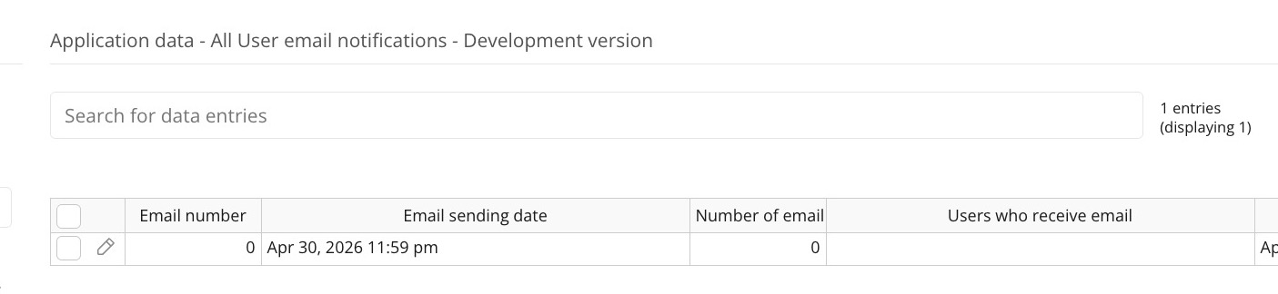

Note: We must find a way to efficiently filter the users who must receive an email

4. Please do your best to write here your version of the algorithm:
- Admin Trigger Button
The process starts when the Admin clicks the “SEND MONTHLY EMAIL NOTIFICATIONS” button on the /monthly-email/ page.
- Search for Users (Subscription-Based Filtering)
The system first searches for users whose subscription status is:
  - Active, or
  - Pending-cancel
- Check User Regulations
From those users, the system further filters only users who have at least one tracked regulation where:
  - New version found date > Last email sent date
- Filtered User List Created
After applying both conditions (subscription + regulation update), we get the final filtered list of users who need to receive the email.
- Send to Backend Workflow
This filtered user list is then passed to a dedicated backend workflow.
The backend processes each user individually to:
  - Retrieve the relevant updated regulations
  - Dynamically generate the email content (Market – Regulation Title)
  - Send the email via SendGrid
- Email Summary Record
A record is created in the “User Email Notifications” table containing:
  - Email number
  - Email sending date
  - List of users who received the email
  - Total number of emails sent (based on the filtered user count)
- Update Last Email Sent Date
After completion, the system updates the global “last email sent date” so that future monthly runs only consider newly updated regulations.

Database tables information

User Subscription’s status:

This is already there:
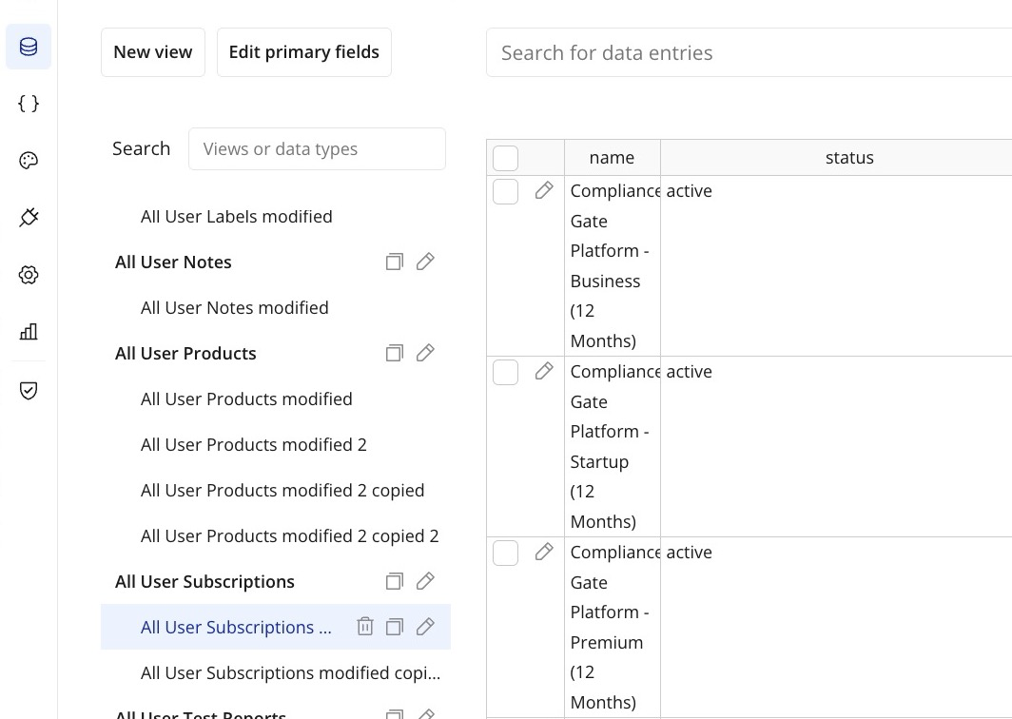

Users’ Tracked Regulations List

This is already there:
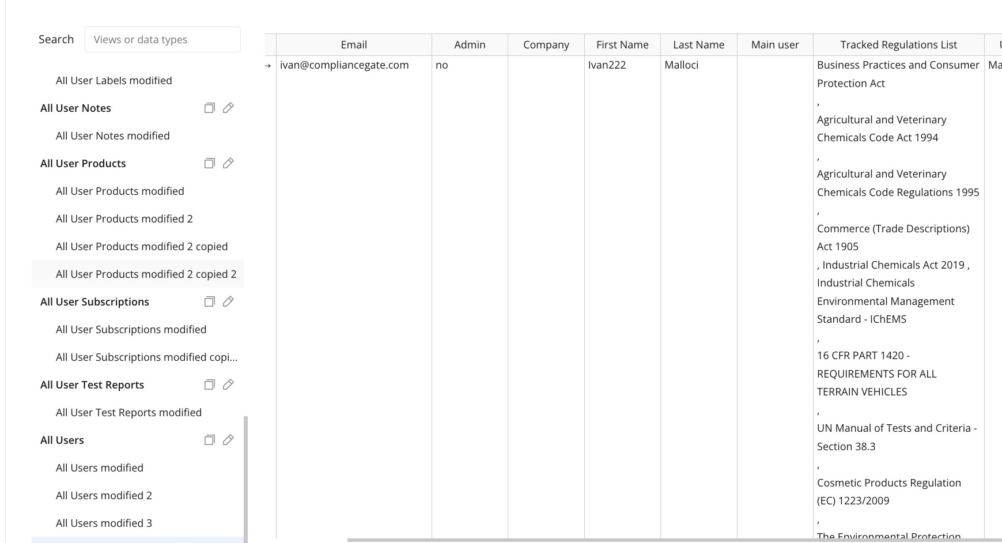

CRL Regulations’ New version found date:

This is already there:
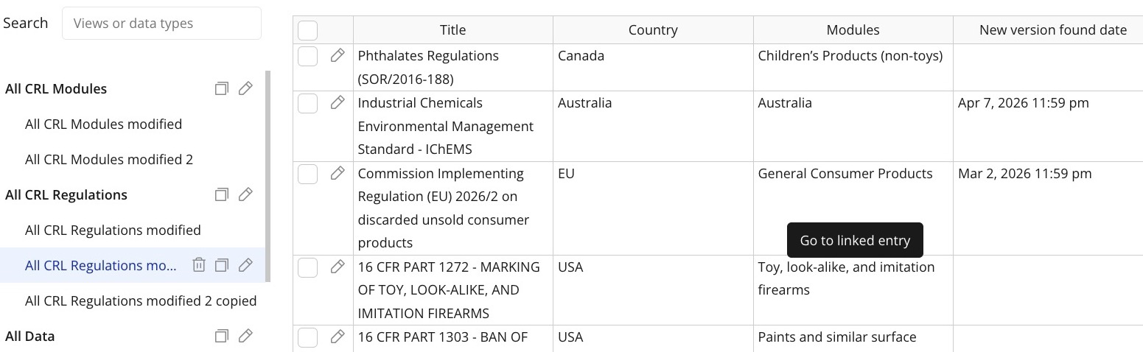

User email notifications:



Email template:

Email Subject: LexDatabase - New Versions Detected

Email Body:

Hello,

New versions of the following tracked regulations were found during our last review:

[Market] - Regulation’s Title
[Market] - Regulation’s Title
[Market] - Regulation’s Title
[Market] - Regulation’s Title
Please sign in to the Compliance Gate Platform to learn more.

Additional information for developer guidelines

Quotation Request
Please fill in the table with your quotation:

Milestone # | Milestone title | Hours | Initial quotation USD (25 USD per hour) | Completion day (estimation)
1 | Page monthly-email + backen/filter logic | 8 | $200 | 2 days
2 | Dynamic email creation + test | 3 | $75 | 2 days
Total |  | 11 | $275 | 4 days

Milestone 1: Technical Implementation & Expert Effort Justification
Below is the detailed breakdown of the technical approach. This plan prioritizes atomic operations and backend scalability to eliminate performance "bottlenecks".
1. Admin Control Plane (/monthly-email/)
Estimated: 2 Hours
- Scope of Work:
- Development of a restricted access page limited strictly to the Admin role.
- State-Based UI: The "SEND" button logic will be bound to a custom state to prevent race conditions or duplicate triggers.
- Real-time execution feedback: Binding the UI to the User email notifications table to display the "Emails were sent on..." confirmation and the specific user list immediately upon workflow completion.
- Expert Justification: Effort covers responsive layout and the "locking" mechanism that ensures the system cannot trigger another workflow until the current list is fully processed.
2. Scalable Backend Filtering & Processing Logic
Estimated: 6 Hours
- Scope of Work:
- Architecture: Utilizing "Schedule API Workflow on a List" to move heavy processing from the browser to the server.
- Conditional Filtering: Constructing a multi-layer filter for users with active or pending-cancel status.
- Regulation Intersection: An expert-level filter comparing each user's Tracked Regulations List against the New version found date to ensure it is strictly greater than the Date in which last email was sent.
- Security Counter: Implementing a server-side safety check to halt execution if the counter exceeds the total user count.
- Expert Justification: This avoids slow "recursive" loops, ensuring the app remains fast even as the user database grows.
3. Transactional Audit Logging & Initialization [SKIP]
Estimated: 3 Hours
- Scope of Work:
- Database Schema: Creating the User email notifications table with fields for Email #, Date, User List, and Total Count.
- Baseline Initialization: Manual entry of the 2026-04-30 baseline to ensure historical updates from early 2026 are ignored.
- Data Integrity: Ensuring the Email # auto-increments and the Date is captured only at the moment of successful dispatch.
- Expert Justification: Proper database design prevents "phantom" records and ensures a clean audit trail for the Compliance Gate Admins.
4. SendGrid Integration & Dynamic Formatting
Estimated: 3 Hours [Reduced to 2]
- Scope of Work:
- Payload Construction: Generating a dynamic string for the email body using the format: [Market] - Regulation Title.
- API Mapping: Connecting Bubble’s backend to the existing SendGrid account and API.
- Clean-up Logic: Managing the "Email sending array" custom state—clearing it after each successful user dispatch to prevent data leakage between recipients.
- Expert Justification: This ensures the dynamic list looks professional and SendGrid's API is utilized efficiently without unnecessary calls.
5. Expert UAT & Edge-Case Testing
Estimated: 2 Hours [Reduced to 1]
- Scope of Work:
- Scenario Testing: Using the test8@compliancegate.com account to verify that users with empty regulation lists do not receive emails.
- Role Validation: Confirming the /monthly-email/ page is unreachable by sub-users or non-admins.
- Logic Verification: Confirming the "strictly greater than" date comparison triggers correctly for new updates.
- Expert Justification: Rigorous testing ensures high-quality code and adherence to the "one developer access" rule.
--------------------------------------------------------------------------------------------------------------------
Quotation Request (Milestone 1): 16 hours
Cost: $400 ($25/hr)
Completion days: 3-4 days

Test Account

You can test current functionalities by logging in here:

Login page: https://dashcgstage.wpengine.com/account/

User: test8@compliancegate.com

Pw: test.2020.2026

Subuser username: test123@compliancegate.com

PW: test.2020.2026

General Guidelines
1. Design shall be responsive

2. If you want to add a plugin, because it is strictly necessary, you must inform us FIRST. Same if you need to change anything that is not related to the page /database (eg. database fields, permissions or something else)

3. You need to make sure that you do not create “bottlenecks” that make the app very slow (we are writing this as we had a similar issue in the past) or consume an unnecessary amount of workflows.

For example, it is not acceptable that the app loads for seconds before showing the database data, when I head to the database table, or when I change a filter

4. You are not allowed to use LLMs to generate design / workflows or code

5. We will need basic documentation - that is one page that explains how the main workflows work.

6. The app has “main users” and “subusers”. The new page / data shall be available to both types of users.

Other
Old guidelines (phase I) are here: https://docs.google.com/document/d/1v7GCMowyv9nSFdguH6FDf8_3iWXFaNJQGR08wTMlJl0/edit?tab=t.0#heading=h.fv1fnrddr6a0

Notes on future milestones [ON hold]

New task
If I tick “Do not allow file uploads” (for security reasons
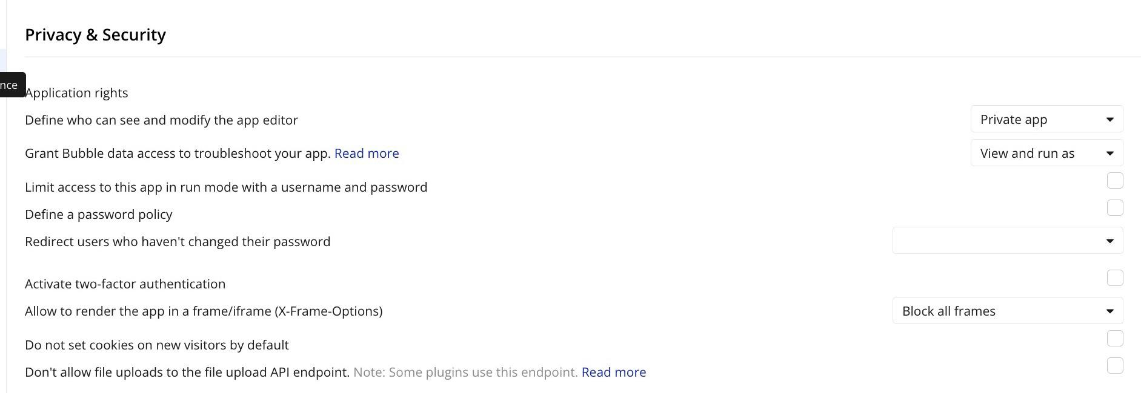

And then I try to add an image to a new product, a label file, a document, see this:

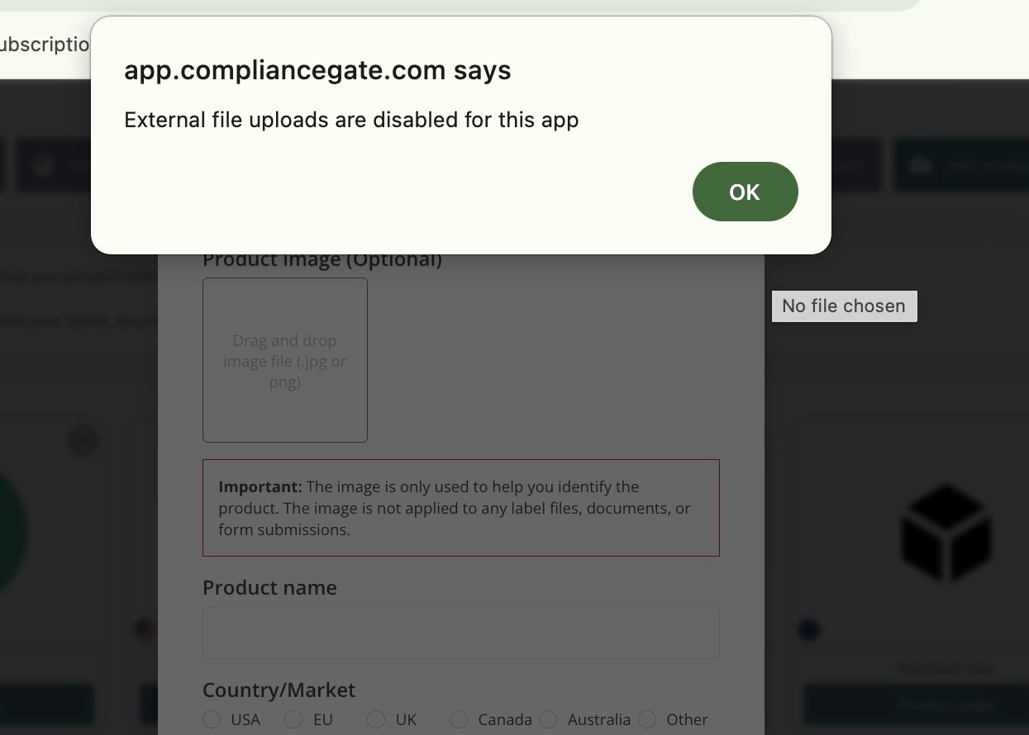

However, if I try to upload a test report, it works fine (see product page):

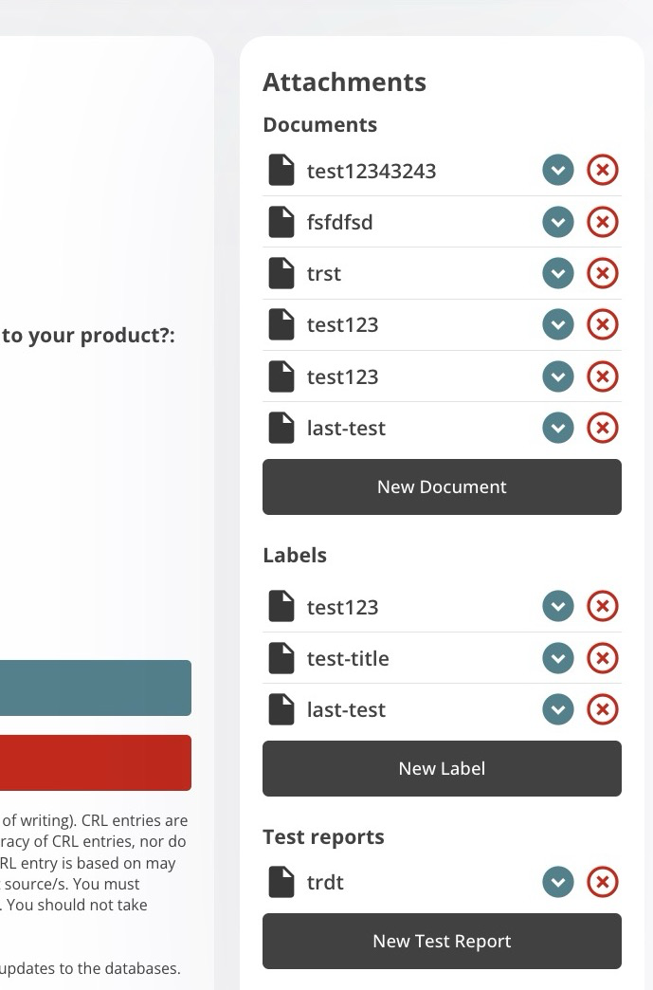

Why is this the case, and how can this be solved? Because of this: https://manual.bubble.io/core-resources/bubbles-interface/settings-tab?_gl=1*18pyznc*_gcl_au*MTUxNTAzMjY3MC4xNzcxMzAxODc3*_ga*Njg2Mzc0NzQxLjE3MzA5NjQ5OTI.*_ga_BFPVR2DEE2*czE3NzU2OTY3ODgkbzMzNCRnMSR0MTc3NTc4NjM2MCRqNjAkbDAkaDA.#dont-allow-file-uploads-to-the-file-upload-api-endpoint

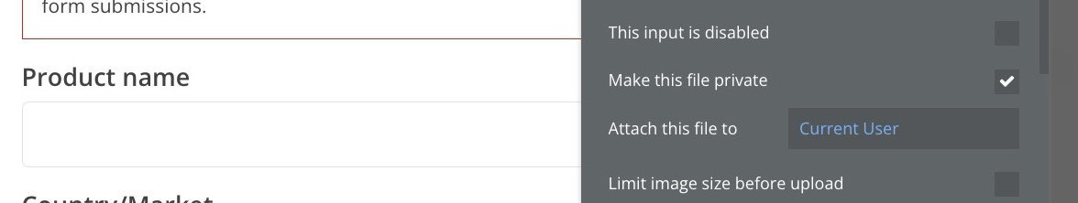

Note: For test reports it is a file uploader:

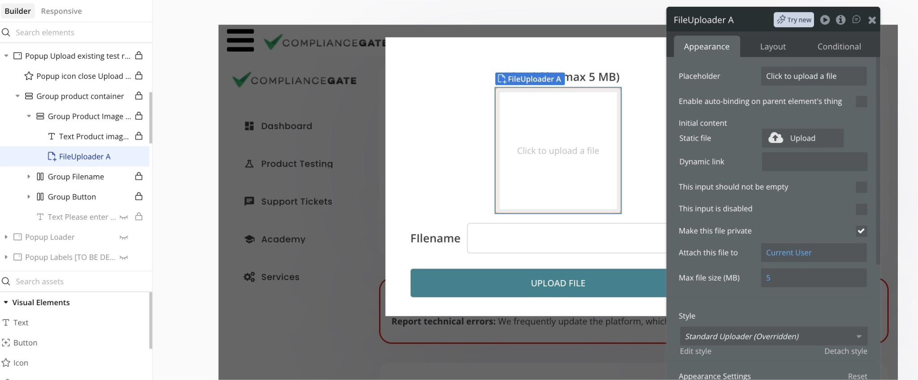
For the others is picture uploader:
